$39,900K
Description
Unique Montecito Heights property with canyon & downtown la city views! 2br/1ba with full basement 1436 sq ft, 2 car off-street parking. This is a major fixer or rebuild & the city will require a retaining wall. Cash, hard money or fha 203k financing only! Bring your handy buyers or investors, won't last long at this value. Please use caution when showing, do not enter structure, may be unstable.
Price Reduced: 09/28/09 -- $119,900 to $99,900
Price Reduced: 10/05/09 -- $99,900 to $89,900
Price Reduced: 10/21/09 -- $89,900 to $84,900
Price Reduced: 11/06/09 -- $119,900 to $84,900
Price Reduced: 11/11/09 -- $84,900 to $79,900
Price Reduced: 11/17/09 -- $79,900 to $69,900
Price Reduced: 12/28/09 -- $119,900 to $69,900
Price Reduced: 01/05/10 -- $69,900 to $59,900
Price Reduced: 01/12/10 -- $59,900 to $49,900
Price Reduced: 02/01/10 -- $49,900 to $45,000
Price Reduced: 02/22/10 -- $119,900 to $39,900

School District: LOS ANGELES UNIFIED
Beds: | 2 | Type: | SFR | Sq. Ft.: | 668 | Lot Size: | 5,706 Sq. Ft.
Baths: | 1/0 | Built: | 1921 | $/Sq.Ft.: | $60 | List Date: | 09/22/09 | On Market: | 168 days

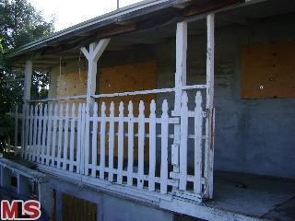
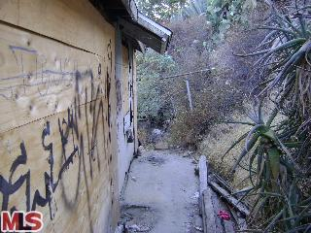

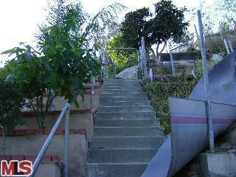
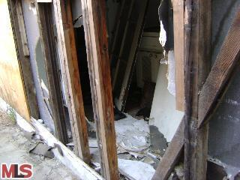

Comparable Homes
LOS ANGELES, CA 90065 2/1 1,436 1908 SOLD 02/04/10 1.0 $325,000
LOS ANGELES, CA 90031 3/3 1,215 1950 SOLD 02/03/10 0.7 $330,000
LOS ANGELES, CA 90065 2/1 1,194 1923 SOLD 02/02/10 0.9 $345,000
LOS ANGELES, CA 90032 3/1 1,096 1927 SOLD 02/02/10 0.9 $102,000
LOS ANGELES, CA 90031 3/3 2,314 1924 SOLD 02/01/10 0.8 $370,000
LOS ANGELES, CA 90031 2/2 1,110 2008 SOLD 02/01/10 0.9 $239,000
LOS ANGELES, CA 90031 3/2 2,455 1925 SOLD 02/01/10 0.4 $181,000
LOS ANGELES, CA 90031 2/2 1,370 2008 SOLD 01/27/10 0.9 $382,500
LOS ANGELES, CA 90031 2/2 1,110 2008 SOLD 01/26/10 0.9 $405,000

